GIT ASSIGNMENTS

SECTION 1:

1. Create an empty directory ‘Assignmrnts & cd to ‘ Assignments’.

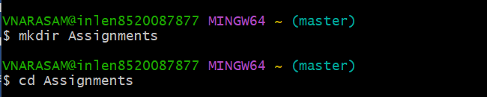

1. Create an README.txt inside ‘Assignments’ & write few lines about the contents of ‘Assignments’ folder.

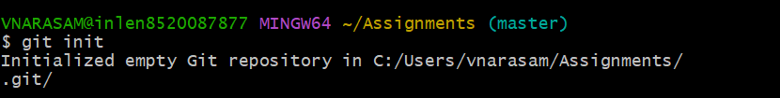

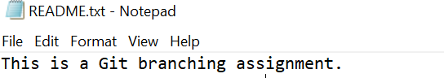

1. Commit README.txt file. 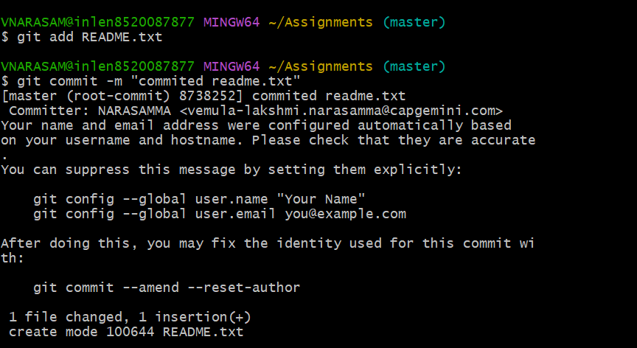

25.Now create a new branch ‘html-assignments’.

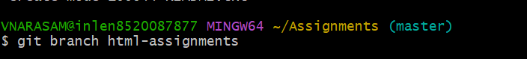

26.Switch to ‘html-assignments’ branch.

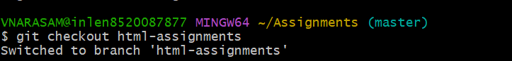

27.Copy all HTML assignments inside ‘Assignments’ folder.

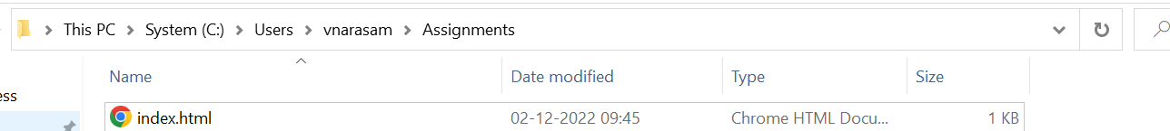

28.commit HTML assignments into ‘html-assignments’.

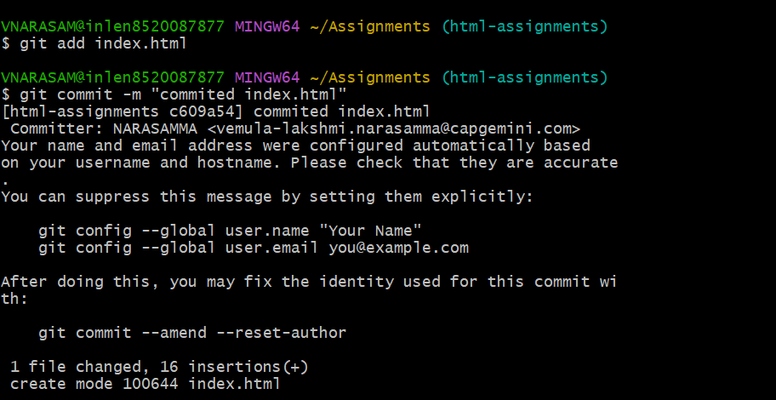

29.Make mionr changes into few files belonging to ‘html-assignments’ branc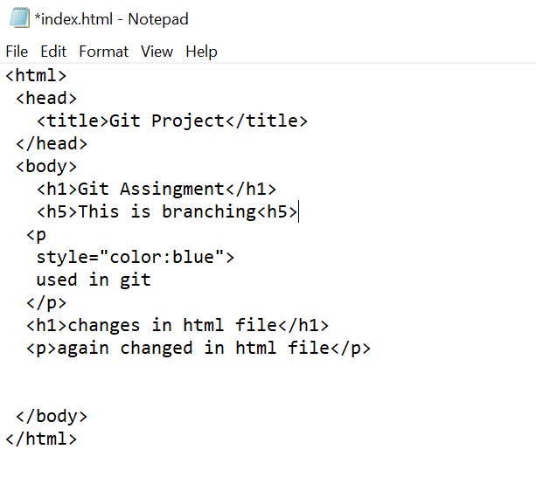h

30.commit those changed files. 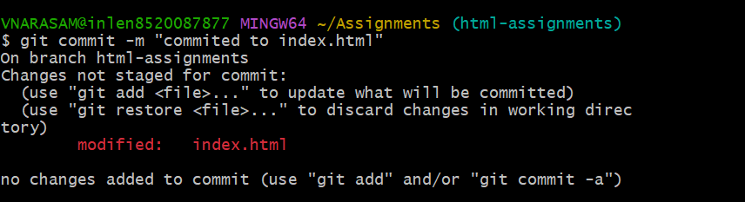

31.Switch to master branch.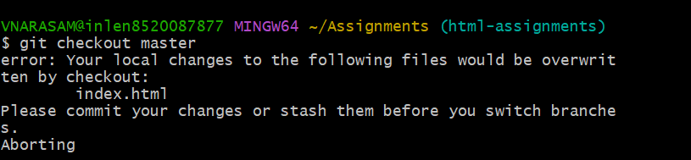

32.Make mionr changes into few files belonging to ‘html-assignments’ branch

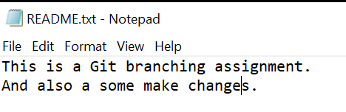

33.Again switch to html-assignments branch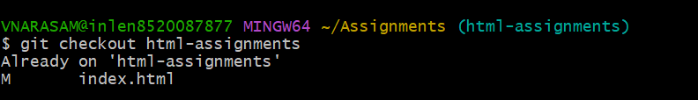

34. Make mionr changes into few files belonging to ‘html-assignments’ branch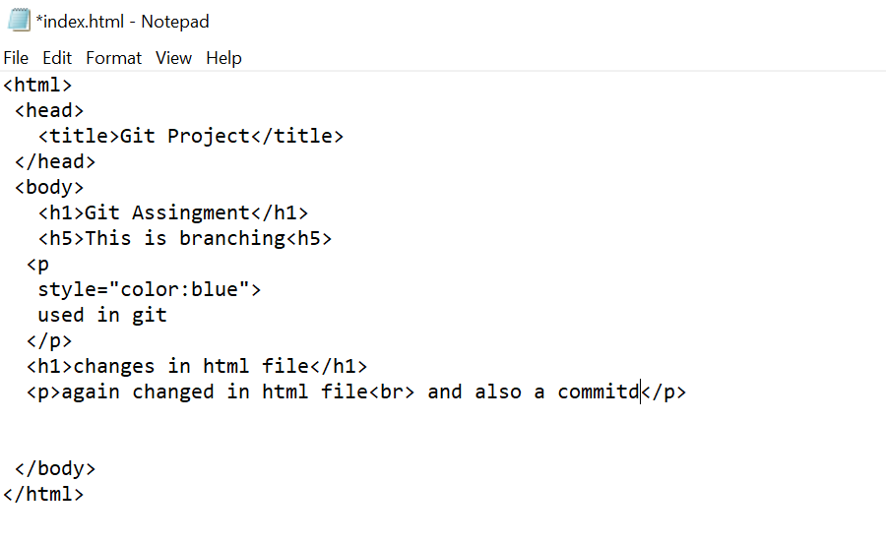

35.commit those changes.

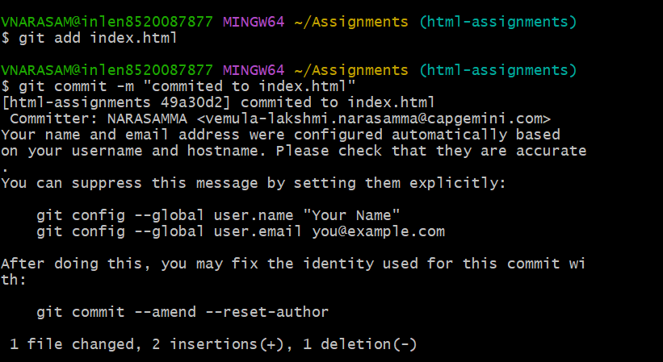

36.switch to master

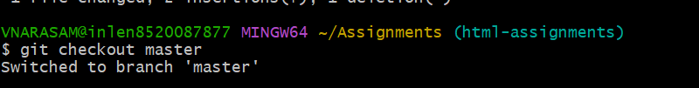

37.Mserge ‘html-assignments’ branch into master. Confirm all html assignments are shown in master

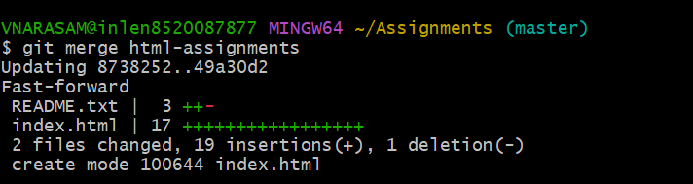

38.Finally delete the ‘html-assignments’ branch.

